To run the WebApp:
- open a terminal in WebApp\mysite
- run the command "python manage.py runserver" (without quotes).

To migrate/reset the database:
Should do this initially, and also any time a change is made to the DB in django. If it says that you have unapplied migrations, do step 3. Also if there is any sort of DB error, you should try steps 1-3.
- delete every file in WebApp\mysite\main\migrations EXCEPT _init_.py
- cd into WebApp\mysite
- run "python manage.py makemigrations", then "python manage.py migrate"

To start the remote DB:

- Go to amazon https://aws.amazon.com/ and click AWS Management Console under My Account

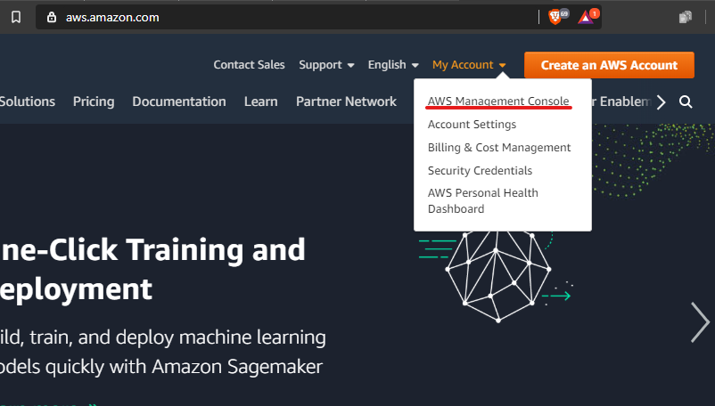

- log in
(Username and password are pinned in the discord general channel)

- click on RDS, you can search for it in the search bar

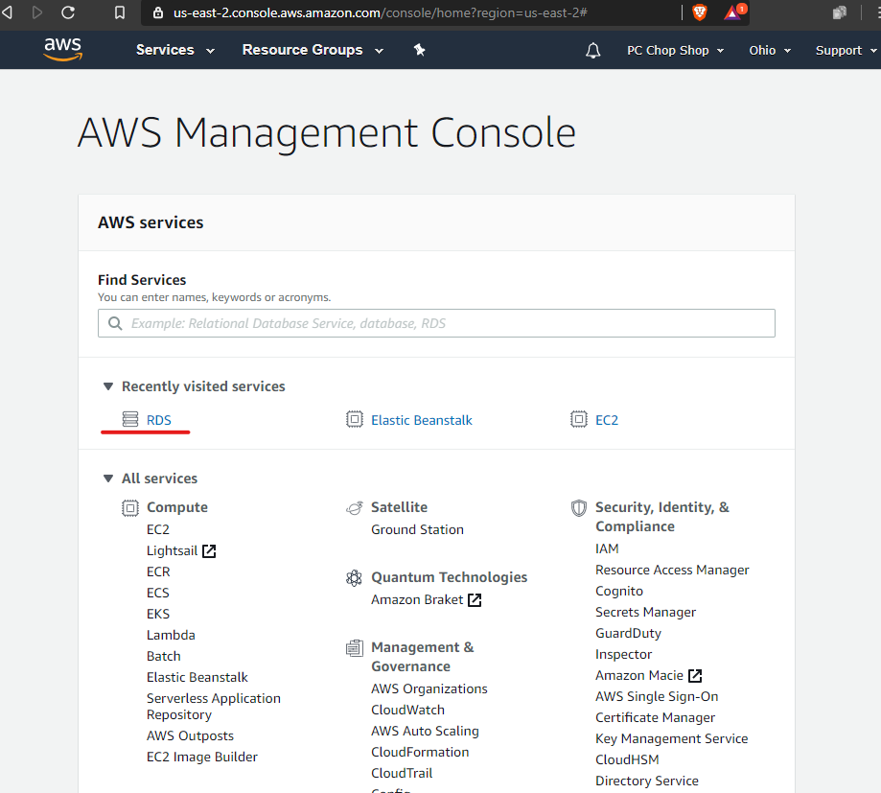

- click on databases or DB instances
Adding you IP to the DB
- At the DB home page click vpc security groups
- Click actions and select edit inbound rules
- Add your public IP
- Save results
- Relaunch python app

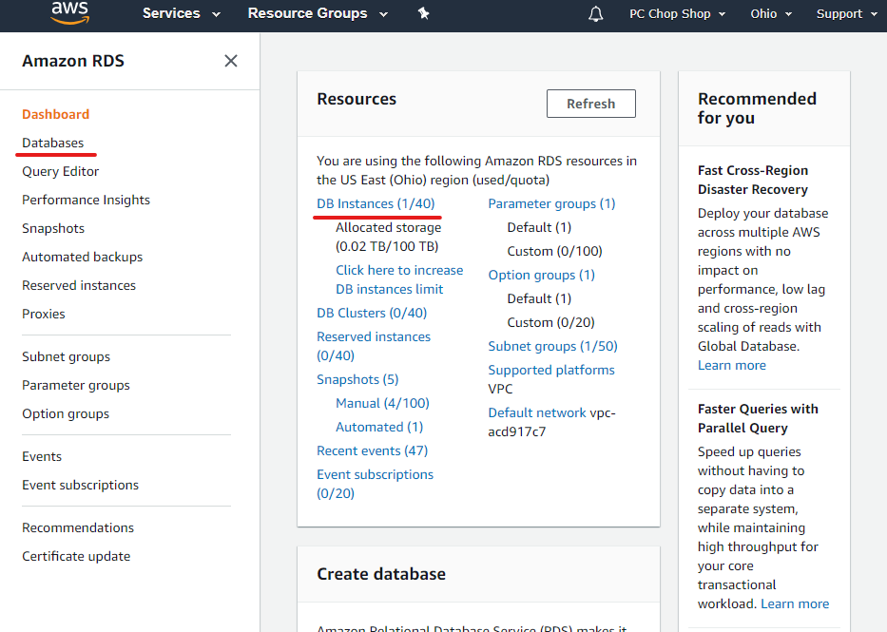

- click on database-1

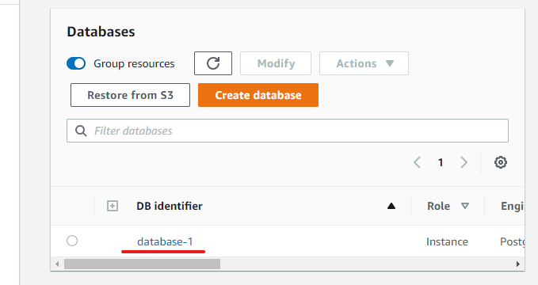

- click start under actions
IMPORTANT NOTE:
To stop the DB, click Stop under Actions. Please do this when you are done working for the day. Kevin’s personal card is on file for this account, so if we go over our usage hours (700hrs/month I think), he gets billed.

